Report of Senior Design Project
Spring 2002 Semester

The University of Illinois at Chicago
College of Engineering
Department of Electrical Engineering

Voice Activated Universal Remote Control

Prepared by: William Newby, Gabriela Bartkowski and Jose Valencia

Technical Faculty Advisor: Professor Robert Becker

CONTENTS

- PROJECT GOALS
1.1. PRODUCT NEED
- TECHNICAL SPECIFICATIONS
- ENGINEERING DESIGN ALTERNATIVES
3.1. DESIGN ALTERNATIVE EVALUATION CRITERIA
3.2. SELECTION OF DESIGN FROM ALTERNATIVES
- DESIGN AND PRODUCT COST ANALYSIS
- DESCRIPTION OF THE USER INTERFACE
- CONCLUSION
6.1. APPENDIX: SCHEMATICS AND DIAGRAMS
6.2. REFERENCES

1.0. PROJECT GOALS

Our objective is to focus on a tangible problem with a product that will be practical, inexpensive, and easy to use while simplifying user interaction. This led us to the design for the “voice-activated universal remote control.”

This device will be somewhat similar to a regular universal remote control. The difference will be that our remote is voice-activated. Instead of having many buttons, it will have a microphone and speaker built in for user interaction. Our device will only have one or two essential buttons such as “program” to access the memory for initial setup of the receiving devices. This device will be user-programmable and will use voice prompting instead of buttons. Our device will not need to be near the user as a regular remote control would in order to operate. This device can be placed anywhere in the room within the infrared signal beam range. This will undoubtedly save a lot of time in terms of not having to look for it each time it is to be used.

Our device will listen for and recognize a set of commands and then send out the appropriate infrared (IR) signal to the receiving module of the TV, VCR, DVD player or cable box. For example, if the user says, “TV on”, it will send out the IR signal that will turn the television on. Our device will also utilize “macros”, enabling the user to assign a series of commands to a specific function. If the user says, “give me entertainment”, our device could be configured to turn on the television, VCR and begin playing a movie. The configuration choice is up to the user to decide what would be most convenient or efficient for them.

The “voice-activated universal remote control” is an electronic product that will make watching movies or television a truly pleasant experience while saving time. It will also be simple to program and easy to use while being very affordable. This report summarizes the market and design research, technical specifications, as well as the procedures involved in the creation of the “voice-activated universal remote control”.

1.1. PRODUCT NEED

How would you like to be able to come into your room, sit back in your favorite chair and without lifting a finger, turn on your television and your VCR and watch your favorite show or movie? Would you like to eliminate the need for multiple remote controls cluttering your home and have only one convenient remote that controls up to four different devices?

Many people hate the idea of looking for multiple remote controls. Sometimes it's just easier to get up and manually turn on the television or the stereo rather than having to look for these remote controls. Often, remotes are far away and the user still has to get up to reach them. Also the user must hold the device in their hand in order to change channels. This is especially burdensome for the elderly or handicapped individuals.

We set out to use our engineering education to implement this design. The "voice-activated universal remote control" is a device, which will greatly simplify our lives. Now, a single remote, which will control up to four different electronic receivers, is all that is necessary. This remote will be mobile, so it can be put anywhere in the room, eliminating the need and time wasted looking for it. The user will simply say an easy to remember user-defined phrase, one that makes sense, (like "channel up"), and this device will recognize it and act accordingly.

To assure optimal satisfaction, our group gave out surveys. Most people stated that their remotes were too big. This device will be fairly small, but since people won't have to hold it to operate it, it really shouldn't matter. Our device will plug into an outlet, allowing the user to minimize battery costs while providing a reliable power source.

2.0. TECHNICAL SPECIFICATIONS

INFRARED SIGNALS AND PROTOCOLS

All infrared remote controls communicate to a receiving device via an infrared signal; however, there is not a universal standard encoding method currently in use. These remote control systems use infrared LED's (light-emitting diodes) as a transmission medium for sending out the IR (infrared) signal in response to user interaction. To enable control to multiple devices such as a TV, VCR, and cable box without interference, these systems generally utilize a header as well as an address to synchronize the receiver and identify the source (and destination) of the infrared signal [4]. The header alerts all infrared receivers in the area to await an incoming command. Then, once the address is acknowledged, the device can start receiving the actual command from the data section of the message. As long as a button is depressed, the command will continually execute. When the button is released, a string of code called the “stop” is transmitted. The stop tells the machine to stop its execution of the command.

Some of the earliest remotes simply used an infrared light-emitting diode to control the system. However, to avoid interference from other light sources and prevent the signal from being flooded out by ambient light, most systems currently modulate the signal with a carrier frequency in the range of 10kHz (kilohertz) to 100KHz. Inside the receiving unit, a band-pass filter allows only the desired frequency to pass through [4].

The figure below shows a modulated IR signal. The IR output is modulated at a specified frequency. Modulating the IR signal produces a signal (command code) with an IR carrier for which the receiver can be tuned to, allowing the rejection of all other IR signals without the appropriate carrier frequency. Once the signal has passed through the filter, it is decoded and executed [5].
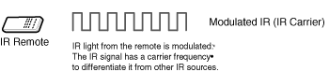
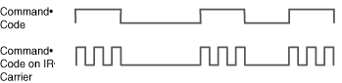
© 2001 RGB Systems, Inc. / DBA Extron Electronics. All rights reserved

Data encoding is accomplished by one of three methods, which are (1) pulse-width modulation, (2) pulse-space modulation or (3) shift coding. Each pulse consists of a burst of infrared light at the carrier frequency. A “high” corresponds to a burst of IR energy at the carrier frequency while a “low” is represented by the absence of IR energy. As mentioned above, there is no encoding standard being used. However, while many devices use their own proprietary schemes for encoding, some standards do exist [4].

Pulse-width encoding, utilized by Sony, is accomplished by varying the length of the pulses while holding the length of the space constant. A logical “zero” corresponds to a pulse-width in the range of 550us (micro-seconds) and a logical “one” is approximately 2200us [6].

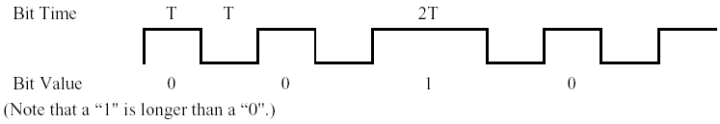

Pulse-space encoding, otherwise known as space-coded or REC-80, popularized by Panasonic, uses space-width modulation that varies the length between the pulses for information coding. A logical “zero” has a space-width of about 550us corresponding to a period of 2T while a logical “one” is approximately 1650us having a period of 3T [6].
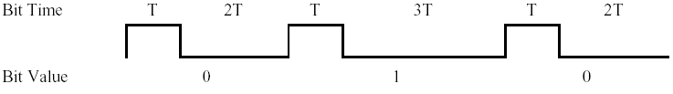 (Note: a “1” has a longer space than a “0”, even though the pulse lengths are identical.)

Shift coding or RC-5, developed by Phillips, is a bi-phase coding method, which assigns a uniform duration to each bit while varying the order of the pulse space. For a logical “one” the space width is short (~550us) and the pulse width is long (~1100us), and is thus a high-to-low transition. Conversely, for a logical “zero”, the space width is long and the pulse width is short, yielding a low-to-high transition. If one or more identical bits are sent in succession, a transition at the beginning of each bit time is necessary to adjust the signal to its proper start level [6].
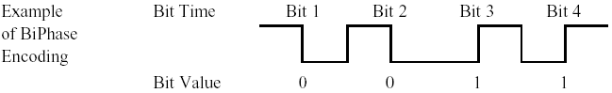

In the RC-5 Scheme, pictured below, the commands are 14 bits long. The first two bits are for initialization and the third bit is for toggle, changing each time a key is depressed. Bits 4-8 are for the address and bits 9-14 determine which command was issued. RC-6 is a new expanded version of RC-5, including a header, control, and information field (1-16 bit length) with a defined “signal free time” between commands [4].
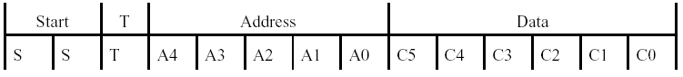

Other variables manufacturers may change include the header, address and data bits, as well as the addition of error checking and “change bits”, enabling the receiver to detect if a button has been pressed twice [4]. For a table of command bit sequence timings for various manufacturers, see the document “IR codes reference table” in the appendix [7].
VOICE EXTREME MODULE / IR REMOTE OPERATION

The Voice Extreme (VE) module (pictured below) is the heart of the voice extreme system. This module contains an embedded 8-bit speech processing micro-controller, the Voice Extreme IC (VE-IC). This micro-controller, combined with a 2-megabyte flash memory, is designed specifically for speech applications in consumer electronics. The J1 connector on the VE module has 34 pins of which 11 are for input/output [10]. For the interconnection interface circuitry to the infrared code-generating IC, the PP4001B, please see the document ”interface circuitry pin connections” located in the appendix.

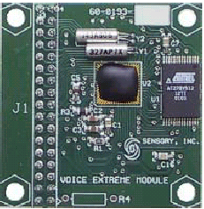

The operation of our system begins when the user speaks a pre-defined, user-trained command into the microphone. To increase or decrease the microphone range, the values for R4 and C28 may be set accordingly to the table in the appendix. This signal goes through a pre-amp to an automatic gain control circuit located on the VE-IC. See the Voice Extreme Module block diagram pictured below [10].
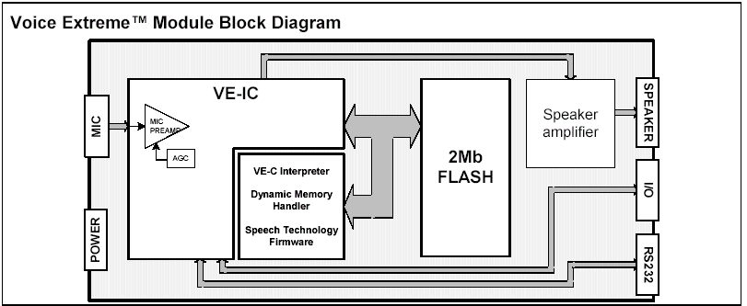

This command is then analyzed with on-chip speech recognition algorithms and compared to the commands programmed in the flash memory located on the VE module. These functions, written in the Voice Extreme (VE-C) language (similar to ANSI C), are invoked depending on the command issued. These functions send an 8-bit word, the simulated button pressed command, to the data register ( port 1 ) and enable a control register ( port 0 ), to read / write from the micro-controller connected to the PP4001B IR engine input via the interface circuitry in conjunction with the I/O section of the VE-IC. A diagram of the VE-IC is pictured below.
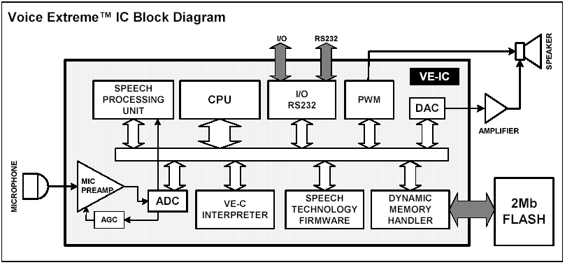

If a command is not understood, the VE-IC issues a prompt to the user through a speaker amplifier circuit connected to a loudspeaker [9]. After this input is received by the PP4001B integrated circuit, it will be modulated with a carrier frequency containing the appropriate signal and is then sent out to a receiver by means of a light-emitting diode. The receiver will then filter this frequency and “strip off” the IR carrier, allowing the reception of the decoded command.

3.0. ENGINEERING DESIGN ALTERNATIVES

In researching this design, we discovered that there are many options available. The design will be influenced by what the user wants as well as how much they are willing to spend. We need to keep our cost competitive with other manufacturers while providing a useful and reliable product.
As mentioned previously, we conducted a survey to determine what the average user expects from a product like this. The results varied but all the users indicated they use a remote with their entertainment devices. The majority of respondents would like the device to be mobile. We asked users if they would prefer either buttons with voice-activation or voice-activation without buttons on the remote. The responses yielded a majority preference for a remote with a combination of both, buttons and voice-activation. However, we also found that most people would not prefer buttons.

After considering these mixed results and re-analyzing the project goals, we decided not to use buttons. However, our device will have two buttons, one for downloading the executable program file to flash memory and a reset button. The survey also determined that most remotes are too large. We will try to keep our remote small, allowing it to be placed near the entertainment device or something similar to these specifications. For complete details, refer to the document “remote control survey results” in the appendix.

Some of the alternatives we considered included: a microprocessor versus an integrated circuit to generate the infrared signals, a choice of the voice recognition software and micro-controller solution and battery operation versus an external power supply. The inclusion of other features such as whether to include buttons and overall size as well as an IR (Infrared) to RF (radio frequency) transmitter and RF to IR receiver interface circuitry were contemplated as well. See the section 3.1 for a table of advantages and disadvantages.

3.1. DESIGN ALTERNATIVE EVALUATION CRITERIA

Below is a table of our considerations for our alternatives that are used to determine the feasibility of choosing a specific alternative.

Option | Advantages | Disadvantages
Pushbuttons | - User can control remote by spoken voice or manually | - Buttons may wear out or break
Without pushbuttons | - Not necessary to touch device  - May leave on table, etc… | - If user wants a choice for input, he is limited to just voice commands
Battery operated | - Mobile | - Batteries will need to be replaced periodically
External power source (wall outlet) | - No need to replace batteries  - Extended range | - Not mobile  - Need additional outlet for power  - Additional cost to add circuitry to step down voltage
Size | - If small, device may be discreetly hidden | - May be easily misplaced by accident
Voice Extreme toolkit | - Low cost for features provided  - Built in speech recognition technology with 8-bit micro-controller  - Development software included  - Prototype area included on programming board  - Award winning technology  - C-like language (high level)  - Companies developing voice activated products confidently installing in their products | - Limited to companies algorithms for speech recognition  - Company may stop manufacturing this part
Other micro-controllers | - More flexibility in the choice of controllers  - Design less dependent on specific micro-processor constraints | - Does not include all the features and interface ability for the same cost  - Might use assembly and would be more difficult to program and increase costs  - Increased cost due to researching DSP and voice recognition
Innotech IC400B universal remote circuit | - Device code library included  - Compatible with over 5000 devices  - Reduced research time  - Increased reliability  - Low cost for features  - Provides additional features that would be unavailable due to limited time frame | - Limited to vendor’s parts  - Part may become unavailable in future
IR/RF to RF/IR conversion device | - Ability to effortlessly send signals throughout home  - Extended range without obstructions | - Possibility of interference with other devices  - Increases production cost

3.2. SELECTION OF A DESIGN FROM ALTERNATIVES

Our choice for voice activation is to use the Sensory Voice Extreme Toolkit due to the low cost and availability of documentation and software (VE-C, a commonly used higher level programming language similar to ANSI C) as well as the reliability and awards received for speech recognition accuracy [11]. Also, since we do not have extensive experience in speech processing, we want to minimize research time while keeping costs to a minimum. Furthermore, this device combines the best of both worlds, speech recognition technology with an integrated 8-bit microprocessor including a prototype area all on one board at a relatively low cost.

The decision of using either an integrated circuit or a micro-controller to generate the infrared signals needs to be made. We are going to use the PP4001B “Universal Remote Control Integrated Circuit”, manufactured by Innotech Systems to generate our infrared signals. Our decision to use this device over the integration of a micro-controller is two-fold. First the cost savings, and second, the increased reliability from the device code library available on the integrated circuit makes this an effective and economical alternative. This circuit works with over 98% of the world’s home entertainment systems. The library includes codes for well over 5,000 TV, VCR, satellite, audio, home theater and cable box models -- more than available from any other source [8].

Using the Voice Extreme Toolkit in conjunction with the PP4001B enables us to have many features that would otherwise be difficult, if not impossible, to design considering our limited time frame. Some of these features include program code read-back, a choice of manual or automatic code search modes, punch through operation as well as the ability to utilize macros for issuing multiple commands simultaneously [10].

An IR to RF transmitter and RF to IR interface circuit that will allow signals to be transmitted effortlessly throughout the home to the specified device will add extra cost and development time to our project. However, it could be an add-on if is determined there will be a demand for this circuitry and if time permits, we will consider this possibility.

- DESIGN AND PRODUCT COST ANALYSIS

We now examine one of the primary aspects of our product, cost. Obviously, if it's too expensive, customers will simply not buy it. If we keep the costs down by only including the value added features we have chosen, then the product should sell itself. Keeping costs under control will allow us to run a profitable business.

To come up with a general cost of manufacturing each device, we researched the cost of each component from several distributors, including Innotech Systems and Sensory. We found that buying in bulk greatly reduced the price of most components. The price of each individual part for fewer than 100 units and over 100 units is listed below.
Item | Prototype | 1-99 units | 100-999 units
PP4001B | $25.00¹ | $25.00¹ | $15.00¹
Voice ExtremeTM  Toolkit | $129.00² | Not Necessary (one time Purchase) | Not necessary (one time purchase)
Voice ExtremeTM  Module | Included with VE toolkit | $59.00² | $46.00²
MC74HC574 Octal 3-State Noninverting D Flip-Flops (2) | $1.11 | $0.93 | $0.74
MC74HC32 Quad 2-Input OR Gate | $0.56 | $0.42 | $0.32
2N3906 PNP Transistor | $0.07 | $0.05 | $0.03
PN2222A NPN Transistor | $0.29 | $0.25 | $0.19
12MHz Ceramic Colpitts Oscillator | $1.14 | $0.76 | $0.46
0.1 uF Capacitors (3) | $0.06 | $0.04 | $0.03
1 uF Capacitor | $0.13 | $0.10 | $0.08
10 uF Capacitor | $0.06 | $0.05 | $0.04
10-ohm resistor | $0.07 | $0.05 | $0.03
20-ohm resistor | $0.08 | $0.06 | $0.04
47-ohm resistor | $0.09 | $0.07 | $0.05
1K-ohm resistor | $0.10 | $0.08 | $0.06
47K-ohm resistor | $0.11 | $0.09 | $0.07
56K-ohm resistor | $0.12 | $0.09 | $0.09
14 pin IC socket | $0.07 | $0.05 | $0.04
20 pin IC sockets (2) | $0.12 | $0.10 | $0.07
40 pin IC socket | $.0.17 | $0.12 | $0.08
20 pin 0.1 female headers (2) | $1.35 | $1.20 | $1.13
20 pin 0.1 male header | $0.78 | $0.63 | $0.56
20 connector wiring cable for I/O | $0.10 | $0.08 | $0.06
IR LED (high output 940nm wavelength) | $1.79 | $1.57 | $1.38
Program LED | $0.12 | $0.10 | $0.07
Total Cost (parts) | $162.49 | $90.79 | $66.62
Note: All resistors and capacitors are rated at ¼ watt. If more than one part is needed, the number is given in parenthesis after the part name.

This table gives a list of the major components of our device and their respective prices. As can be seen, the bulk price is much cheaper. Specifically, a component such as the PP4001B integrated circuit costs $25.00 if purchased individually [1]. However, purchasing 100 units greatly reduces this price to $15.00. This is a 40 percent savings! The total cost for all components is similar. Purchasing the Voice ExtremeTM Module in bulk saves us 22 percent. The cost per unit of a single "voice-activated universal remote control" is $162.49 for the prototype and $90.79 when purchasing between 1 and 100 units [2]. Since we will be buying over 100 units, the prices will be $162.49 for the prototype, and $66.62 for each additional device. After the prototype has been built, we will only need to purchase one Voice ExtremeTM Module, since the programmer may be re-used to program future Voice Extreme IC’s. This will greatly reduce our price. Mass production saves our company over 27 percent.

Labor is another factor to take into consideration. In order to sell our product we must be able to cover production costs (including parts and labor) and still make a profit. We are estimating that the prototype would take us 40+ hours to assemble plus additional hours for testing. Assuming we're getting paid $25.00 an hour, it would cost us around $3,000.00 for our labor to make the prototype. Added with the cost of parts and rent (assuming $2000.00 a month) the total amount for the prototype would cost us $5,162.49. The mass production time would be on a scale of minutes and not hours. We are estimating that it would take 10 minutes to make each device when mass-produced. Assembly technicians would receive $10.00 per hour yielding a cost of $1.67 for the labor per device.

When producing less than 100 units, the total cost is $5254.95. When manufacturing over 100, units the total cost would be $5230.78. Since we are building over 100 units, in order to make a profit, we will sell our product for $136.58. This is a great price for a voice-activated universal remote control. At this price, we will need to sell only 39 units to break even. When we sell 100 units, we will make a profit of $7,561.51 (100 x $127.24 - $5,162.49). The table below summarizes these calculations:

Cost | Prototype | 1-99 Units | 100-199 Units
Parts | $162.49 | $90.79 | $66.62
Labor | $3000.00 | $1.67 | $1.67
Rent/month | $2000.00 | $2000.00 | $2000.00
Total cost | $5162.49 | $5254.95 | $5230.78
Selling price | $6324.98 | $184.92 | $136.58
Break-even point - (number of units needed to sell) | 0.816 units | 28.417 units | 38.298 units
Notes:
Labor for one hour per engineer is $25.00 (This assumes a $48,000.00 salary for each engineer).
Labor for 3 engineers per hour is $75.00.
For 40 hours development time with three engineers working, the cost is $3000.00.
Rent is approximately $2000.00 per month.

After the prototype is made, labor is $10.00/hr for technicians (Q/A) personnel. This will take ten minutes per device to manufacture.
This corresponds to ($10.00 / 60 minutes) * (10 minutes) = $1.67 per device.

The selling price was calculated by using twice the (parts + labor) only, except for the prototype for which rent is included. The break-even point is the total cost divided by the selling price. For the rest of the total costs (1-99 and 100-199 units), the prototype total cost was added with the individual unit parts and labor costs to recover our costs we arrived at the following prices:
1-99 units = ($5162.49 + $90.79 + $1.67) = $5254.95
100-199 units = ($5162.49 + $66.62 + $1.67) = $5230.78

Tash Inc. is selling an "affordable" voice activated universal remote control for $800.00 [3]. This remote has some extra features such as access to telephone and lighting, but if you want to use them you have to purchase additional modules. It also has a speed-dial option for up to 10 people by name alone. Again, an optional phone is required to use this. For $800.00, the user is receiving a few extra features than our device will have. If a user wants to use the extra devices, they will pay even more. Our product is designed to mimic many of their best features, but we will include only those features that will make this device affordable. Our device will cost only $136.58. Even with a substantial mark-up to cover our operating costs, we can still beat our competition by delivering a well-engineered product at a great price.

5.0. DESCRIPTION OF THE USER INTERFACE

The initial setup will be the same as outlined below, however the user must train the remote with the commands that will enable these functions. When programming the remote, an led will flash each time a code or command has been entered to let the user know it has received the code. These spoken commands will then operate the device. The commands trained must be in the following order, however the user may assign any word to these commands.

SUGGESTED VOCABULARY AND ORDER OF TRAINING
COMMAND # COMMAND NAME COMMAND FUNCTION
1 TRAIN Trains commands (re-trains if called after initial
setup).
2 SAY COMMANDS Speaks the commands currently trained.
3 ZERO # 0 button pressed
4 ONE # 1 button pressed
5 TWO # 2 button pressed
6 THREE # 3 button pressed
7 FOUR # 4 button pressed
8 FIVE # 5 button pressed
9 SIX # 6 button pressed
10 SEVEN # 7 button pressed
11 EIGHT # 8 button pressed
12 NINE # 9 button pressed
13 ENTER ENTER button pressed
14 SILENT MUTE button pressed
15 LOUDER VOLUME UP button pressed
16 SOFTER VOLUME DOWN button pressed
17 NEXT CHANNEL CHANNEL UP button pressed
18 CHANNEL BACK CHANNEL DOWN button pressed
19 REWIND REWIND button pressed
20 PLAY PLAY button pressed
21 FAST FORWARD FAST FORWARD button pressed
22 RECORD RECORD button pressed
23 STOP STOP button pressed
24 PAUSE PAUSE button pressed
25 POWER POWER button pressed
26 RECALL RECALL button pressed
27 TV / VCR TV / VCR button pressed
28 PROGRAM PROGRAM button pressed
29 TV SOURCE1 button pressed
30 VCR SOURCE2 button pressed
31 DVD SOURCE2 button pressed
32 CABLE SOURCE4 button pressed

COMMAND DESCRIPTION
Device Commands:
[SOURCE1] [SOURCE2] [SOURCE3] [SOURCE4] These commands are used to select the device to control. For example, the [CABLE] command switches the remote to CABLE mode and the remote control functions control the cable box. Saying TV switches the remote to TV mode. Some controls may function even when their normal device is not selected (Punch Through). For example, when in cable box mode, the volume controls may still work with the television, and the VCR controls may still control the VCR. The availability of this feature depends on the type of TV, VCR, and cable box.

[Power] This command is used to turn the TV, VCR, or cable box on or off. [CH+][CH-] Channel Up / Channel Down
[VOL+][VOL-] Raise or lower the volume.
[PLAY][FF][REW][PAUSE][STOP][REC] These operate as conventional VCR controls.
[TV/VCR] Toggles between TV and VCR functions.
[MUTE] This command turns muting on and off.
[ENTER] Some TV’s require [ENTER] be input when changing channels.
[RECALL] Returns to the previous channel selected on TV’s that support this function.

PROGRAMMING GUIDE
QUICK PROGRAMMING GUIDE
Speak the device command for the device you wish to program (1 flash)
[TV] or [VCR] or [DVD] or [CABLE]

Give the PROG command (2 flashes) [PROG] ''
Input the corresponding code from the code list. (Flashes once for each digit pressed) [1]' [2]' [3]'

When you have entered the correct code, say PROG. (3 flashes) [PROG] '''
Repeat steps 1-4 for each device (TV, VCR, or cable box.)

DETAILED PROGRAMMING GUIDE
To program A Device:
1. Select the device you wish to program with a device key (TV, VCR, Cable). For instance to program the VCR, say VCR. The light on the remote will flash once.
2. Say program [PROG]. The light will flash twice.
3. Find the correct code from the code list that follows. If a brand has more than one code, the first codes are the latest models.
4. Speak the correct code. The light will flash once for each digit entered.
5. Say program [PROG] again to lock in the code.
The light should flash 3 times, and programming is finished. For example, to program a Sony TV: First, find the Sony codes in the code list. Then, try the first (latest model) code. Say: [TV] [PROG] [0] [3] [8] [PROG]
When finished, try to operate the TV using the remote. If the remote works with the TV, the programming for the TV is finished. If the remote does not work, try the next code: 141, and so on, until the correct code is found.

SPECIAL FEATURES
The PP4001 Universal Remote Control Integrated circuit has several special features:

Punch Through
Some TVS, VCRs, and cable box controls may work at the same time. For example, after you say [C/SAT] or [VCR], the volume controls may still work with the television. Other functions may also work this way. Availability of this feature varies depending on the type of TV, VCR, and cable box used.

Substitute Devices
Users can substitute devices with universal remote controls based on the PP4001. All of the four device buttons (SOURCE1, SOURCE2, SOURCE3 and SOURCE4) can be programmed as either a TV, VCR, DVD, or cable box. To program a TV on the VCR device command:
1. Say [VCR] and then [PROG]. The light will flash twice.
2. Instead of entering a VCR code, enter the TV code for the desired TV. The light will flash once for each digit.
3. Say [PROG], and the light will flash 3 times.
Now the VCR button will act as a second TV.
This works with all four devices, so it is possible to program up to four TV’s, VCR’s, DVD’s, or cable boxes.

- CONCLUSION

Planning this project gave us some insight on what it takes to be successful as engineers. We must budget our time and money while researching and working together as a team to accomplish our goals and meet our deadlines. Also we must design a product that has a competitive price and is of high quality.
The voice activation aspect gave us many problems with background noise which fooled the device into thinking it was receiving a command. In the future, it would have helped to do more research on the problems associated with speech recognition and voice activation in consumer electronics. Implementing this project was an excellent learning experience. It allowed us to actually get a taste of what it would be like working on an actual project as engineers.
Our "voice-activated universal remote control" will undoubtedly simplify our lives by providing a very convenient way to control our home-entertainment systems. We set out to design a product that would be practical, inexpensive, and easy to use. We have met our goals and are confident that we will beat our competition by delivering a well-engineered product at a great price.
Other companies are selling "affordable" voice-activated remote controls, but their prices are much higher than ours. Their products cost more due to some extra features, which our product does not have. Some features include access to a telephone with speed-dial options for up to 10 people, as well as controls for lighting. To use these options you must purchase "extra modules" as well as an optional phone for the speed-dial. All of the aforementioned features will significantly increase the cost. We decided that keeping the cost down was more important than including these features. We look forward to seeing this product as an effective seller on store shelves.

6.1. APPENDIX: SCHEMATICS AND DIAGRAMS

INDEX OF DEVICE CODES
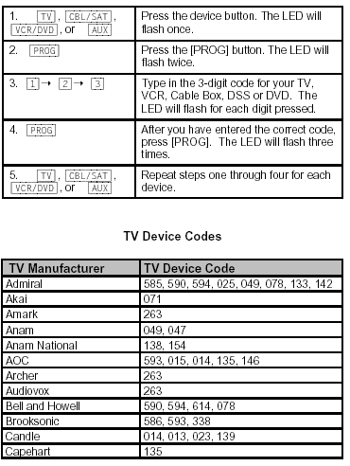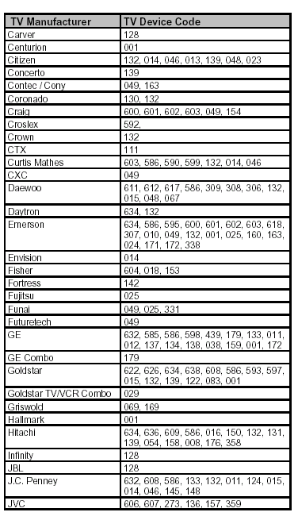

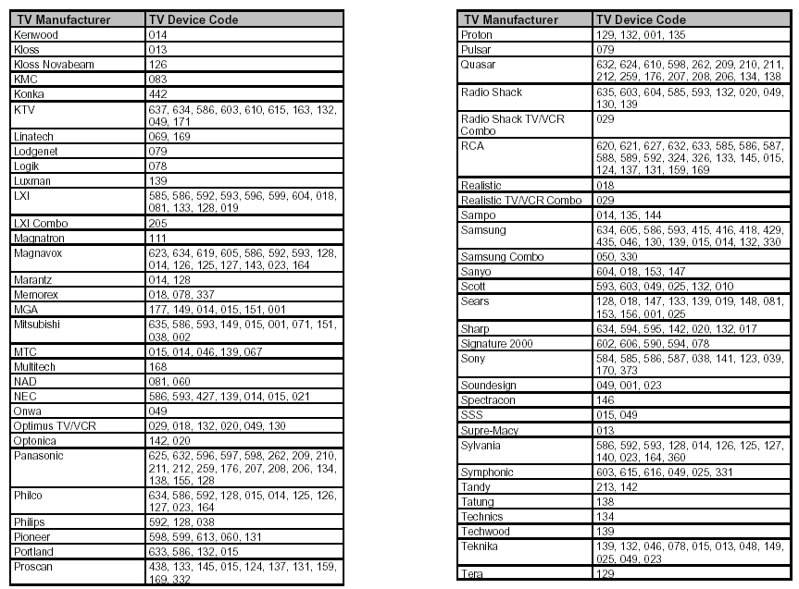
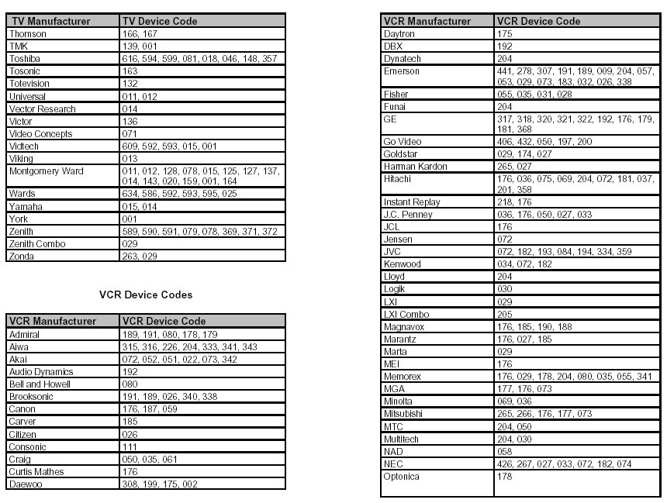
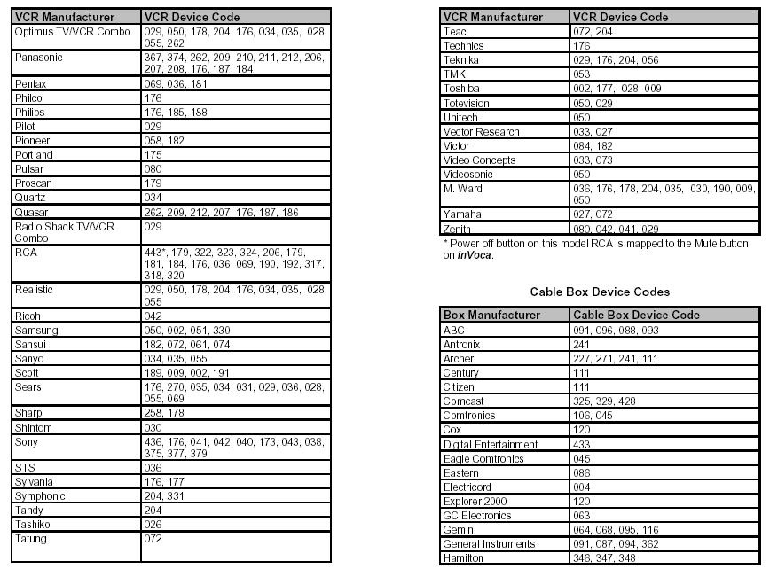
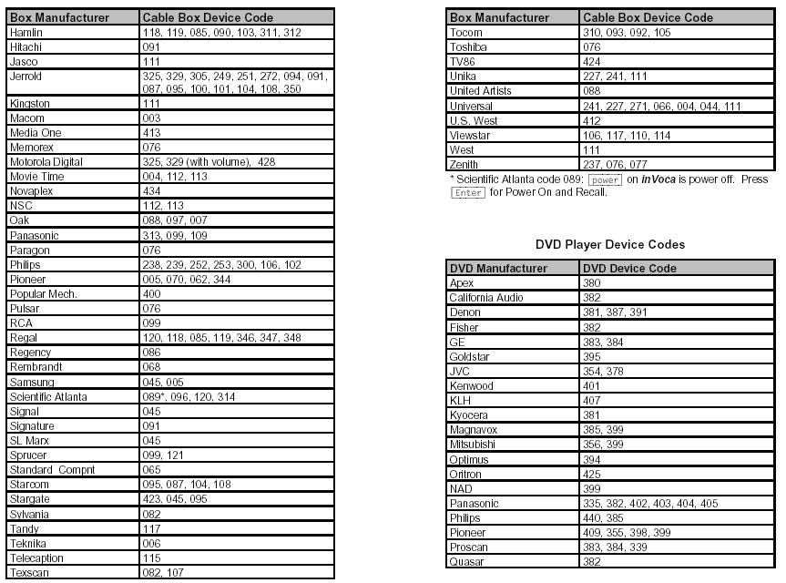
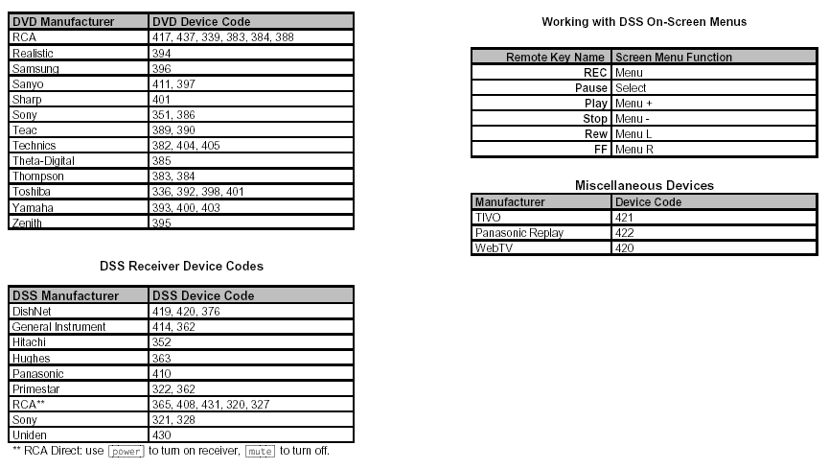

IR CODES REFERENCE TABLE

This table contains a short description of all the remotes supported.
It can be of some help when trying to make new remotes.
All numbers are time in us (micro seconds).

Brand Length Type HeadP HeadS 1Pulse 1Space 0Pulse 0Space Space
--------------------------------------------------------------------------------------
Akai 32 Space 8800 2200 550 1650 550 550 11000
Akai stop 0 None 8800 4400 550 0 0 0 83000
--------------------------------------------------------------------------------------
Canon 32 Space 8800 4400 550 1650 550 550 40000
--------------------------------------------------------------------------------------
Denon 15 Space 0 0 275 1900 275 775 43000
--------------------------------------------------------------------------------------
Finlux pre 10/16 Shift 500 5200 500(1) 530 500 530(1) 105000
Finlux 10/16 Shift 500 5200 500(1) 530 500 530(1) 105000
Finlux post 10/16 Shift 500 5200 500(1) 530 500 530(1) 105000
--------------------------------------------------------------------------------------
Funai 24 Space 3200 3200 800 2400 800 800 30600
--------------------------------------------------------------------------------------
Goldstar 32 Space 8800 2200 550 1650 550 550 11000
Goldstar stop 0 None 8800 4400 550 0 0 0 83000
--------------------------------------------------------------------------------------
Grundig pre 10 Shift 500 2600 500(1) 550 500 550(1) 18000
Grundig 10 Shift 500 2600 500(1) 550 500 550(1) 120000
Grundig post 10 Shift 500 2600 500(1) 550 500 550(1) 120000
--------------------------------------------------------------------------------------
Hitachi 32 Space 8800 2200 550 1650 550 550 11000
Hitachi stop 0 None 8800 4400 550 0 0 0 83000
--------------------------------------------------------------------------------------
JVC 16 Space 2080 4160 520 1560 520 520 20500
--------------------------------------------------------------------------------------
Kenwood 32 Space 8800 2200 550 1650 550 550 11000
Kenwood stop 0 None 8800 4400 550 0 0 0 83000
--------------------------------------------------------------------------------------
Mark sample 17 Space 8400 4200 500 1500 500 500 4000
Mark part 1 8 Space 8400 4200 500 1500 500 500 0
Mark part 2 8 Space ---- ---- 500 1500 500 500 10000
--------------------------------------------------------------------------------------
Mitsubishi 16 Space ---- ---- 300 1950 300 880 24300
--------------------------------------------------------------------------------------
Nec 32 Space 8800 2200 550 1650 550 550 11000
Nec stop 0 None 8800 4400 550 0 0 0 83000
--------------------------------------------------------------------------------------
Onkyo 32 Space 8800 2200 550 1650 550 550 11000
Onkyo stop 0 None 8800 4400 550 0 0 0 83000
--------------------------------------------------------------------------------------
Orion 33 Space 9000 4450 550 1650 550 550 34200
--------------------------------------------------------------------------------------
Old Panasonic 22 Space 3650 2750 910 2750 910 910 41130
Old Pana. US 22 Space 3375 2530 844 2530 844 844 37980
--------------------------------------------------------------------------------------
Panasonic 48 Space 4000 1600 400 1200 400 400 76000
--------------------------------------------------------------------------------------
Philips 14 Shift ---- ---- 889 889 889 889 24889
--------------------------------------------------------------------------------------
Pioneer 32 Space 8000 4000 500 1500 500 500 62000
--------------------------------------------------------------------------------------
Salora 12 Space 50 550 0 375 0 190 238000
12 Space 50 550 0 375 0 190 238000
--------------------------------------------------------------------------------------
Sanyo 32 Space 7850 4200 525 1575 525 525 23000
--------------------------------------------------------------------------------------
Schneider 12 Space ---- ---- 1250 450 450 1250 34200
--------------------------------------------------------------------------------------
Sharp 17 Space ---- ---- 275 1900 275 775 43000
--------------------------------------------------------------------------------------
Sony 15 Pulse 2200 550 1100 550 550 550 23000
--------------------------------------------------------------------------------------
TEAC 32 Space 8800 2200 550 1650 550 550 11000
TEAC stop 0 None 8800 4400 550 0 0 0 83000
--------------------------------------------------------------------------------------
Old Technics 22 Space 3650 2750 910 2750 910 910 41130
Old Techn. US22 Space 3375 2530 844 2530 844 844 37980
--------------------------------------------------------------------------------------
Technics 48 Space 4000 1600 400 1200 400 400 76000
--------------------------------------------------------------------------------------
Yamaha 32 Space 8800 2200 550 1650 550 550 11000
Yamaha stop 0 None 8800 4400 550 0 0 0 83000
-------------------------------------------------------------------------------------

INTERFACE CIRCUITRY PIN CONNECTIONS BETWEEN THE VE-IC AND THE PP4001B IC

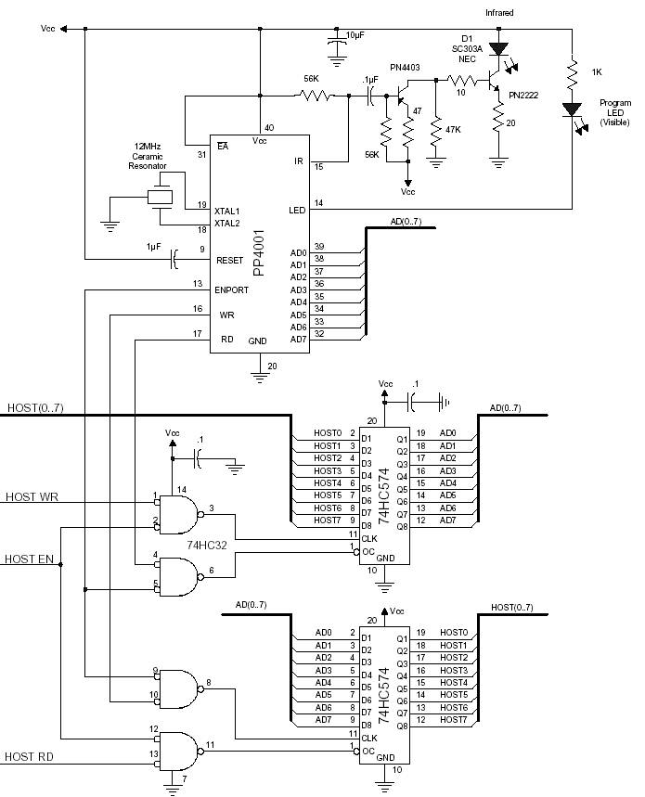
To VE-IC port1, Pins P1.7-P1.0
To VE-IC port0, pin P0.2
To VE-IC port0, pin P0.1
To VE-IC port0, pin P0.3

VOICE EXTREME MODULE SCHEMATIC
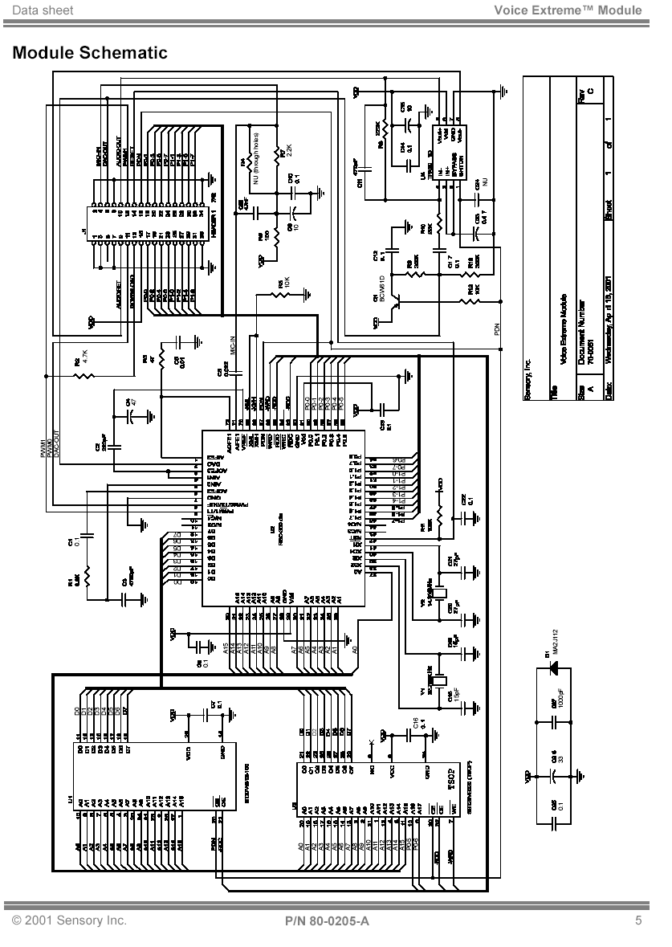

VOICE EXTREME INTEGRATED CIRCUIT SCHEMATIC

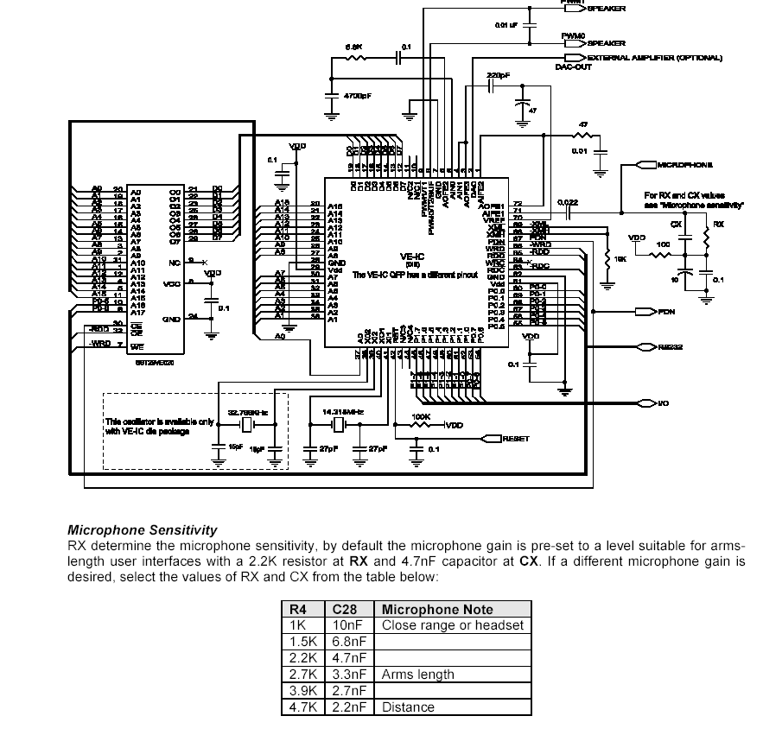

MICROPHONE SENSITIVITY SETTINGS

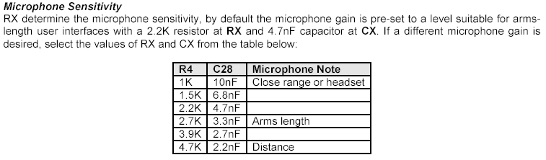

VOICE EXTREME MODULE J1 CONNECTOR PIN TABLE
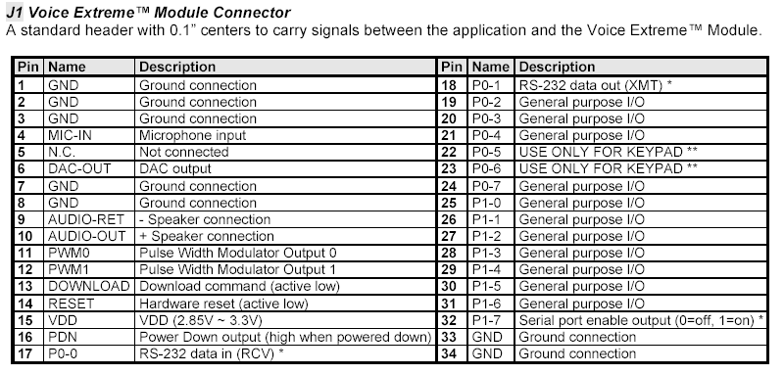

OPERATING RANGE FOR THE PP4001B
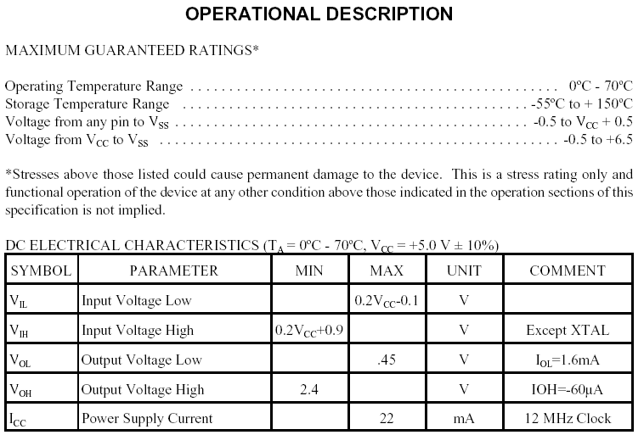

OPERATING RANGE FOR THE VOICE EXTREME IC (VE-IC)
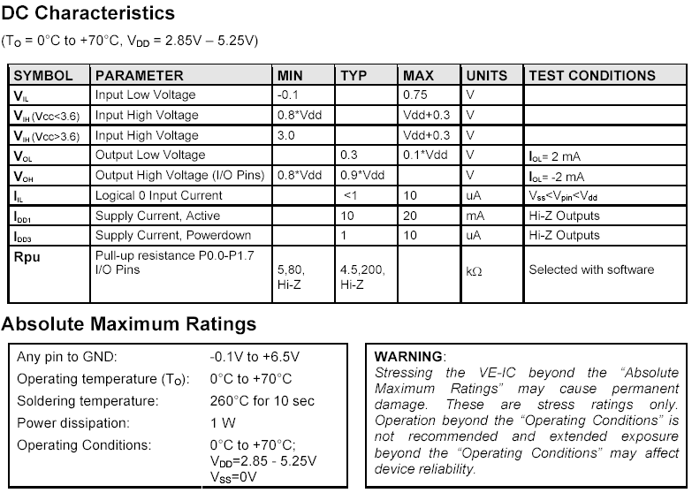
REMOTE CONTROL SURVEY RESULTS
SURVEY GROUP SIZE = 24 PEOPLE
Do you own a television and a computer?
Television 1 | Computer 0 | Both 23

If you own a computer, would you like to be able to download new devices for your remote via computer as they become available?
Yes 20 | No 2

Which brand of TV and or VCR / DVD do you own?
Sony 18 | Panasonic 10 | JVC 2
RCA 5 | Mitsubishi 2 | Sanyo 2
Toshiba 4 | GE 2 | Zenith 1
Other (if choosing other – Please list manufacturer if known) (2 - 1 Samsung, 1 Sharp)

Do you use a remote with your TV / VCR / DVD player?
Yes 24 | No 0

Which features do you use most often (list in order of most used 1-10, 1 being the most used, 10 being the least).
Input Select | Menu | Play | Fast Fwd | Rewind
Pause \ Slow | Stop | Eject | TV/VCR | #1-9, 0
Are there any features that you would like to have that are not currently on your remote?
I always forget what time it is and miss my favorite shows, if it could remember to go to “friends” at 7:00 PM on Thursdays on channel 5, that would be cool.
Are the buttons easy to find and conveniently placed?
Yes 23 | No 1

Would you prefer not to have buttons?
Yes 15 | No 9

Is your remote too large or too small?
Too large 4 | Too Small 2 | Don’t Care

Would you like the remote to be battery operated? (if not you will no longer need to change the batteries)
Yes 10 | No 14

Would you prefer a voice-activated remote over a pushbutton remote or a combination of both?
Voice-Activated w/o buttons 5 | Pushbuttons 3 | Combination 16

Would you like the voice-activated remote to be stationary or mobile (i.e. Leave on table in your room by devices or hold in hand) and if so, would you mind if it needed to be plugged into the wall outlet?
Stationary 3 | Mobile 21

Mind if need to be plugged in?
Yes 16 | No 8
Any other suggestions you have for improvements and or you feel may be beneficial to future consumers.
I think having a voice-activated remote is a very good idea, this will save some time for people.
If it is plugged in, it should be able to receive input from a longer range.
6.2. REFERENCES

[1] Price List and Ordering Information, Innotech Systems Inc., 2001.
www.innotechsystems.com/order.htm

[2] Sales Order Form, Sensory Inc., 2001.
http://www.sensoryinc.com/html/sales/orderform.pdf

[3] Affordable Voice-Activated Universal Remote Control #8600, Tash Inc., 2001. www.tashinc.com/catalog/env_sicare.html

[4] A Primer on Remote Control Technology, Innotech Systems Inc., 2001.
http://www.innotechsystems.com/primer1.pdf

[5] Wireless vs. Wired: Modulated and Un-modulated IR, Extron Electronics, 2001. http://www.extron.com/technology/archive.asp?id=tech96

[6] Infrared Remote Controls: How they Work, University of Washington, 2001. http://www.ee.washington.edu/conselec/A95/projects/pierreg/works/works.htm

[7] Dave Negro, Remote Control table, 2001.
http://www.gis.net/~dnegro/IR/REMOTES/TABLE.HTML

[8] PP4001B Universal Remote Control Integrated Circuit, Innotech Systems Inc., 2001. http://www.innotechsystems.com/pp4001.pdf

[9] Voice Extreme IC: Speech Recognition Controller, Sensory Inc, 2001
http://www.voice-extreme.com/html/support/docs/80-0204-B.pdf

[10] Voice Extreme Module: Speech Recognition Module, Sensory Inc., 2001
http://www.voice-extreme.com/html/support/docs/80-0205-B.pdf

[11] Voice Extreme Programmers Manual, Sensory Inc, 2001.
http://www.voice-extreme.com/html/support/docs/80-0200-C.pdf

